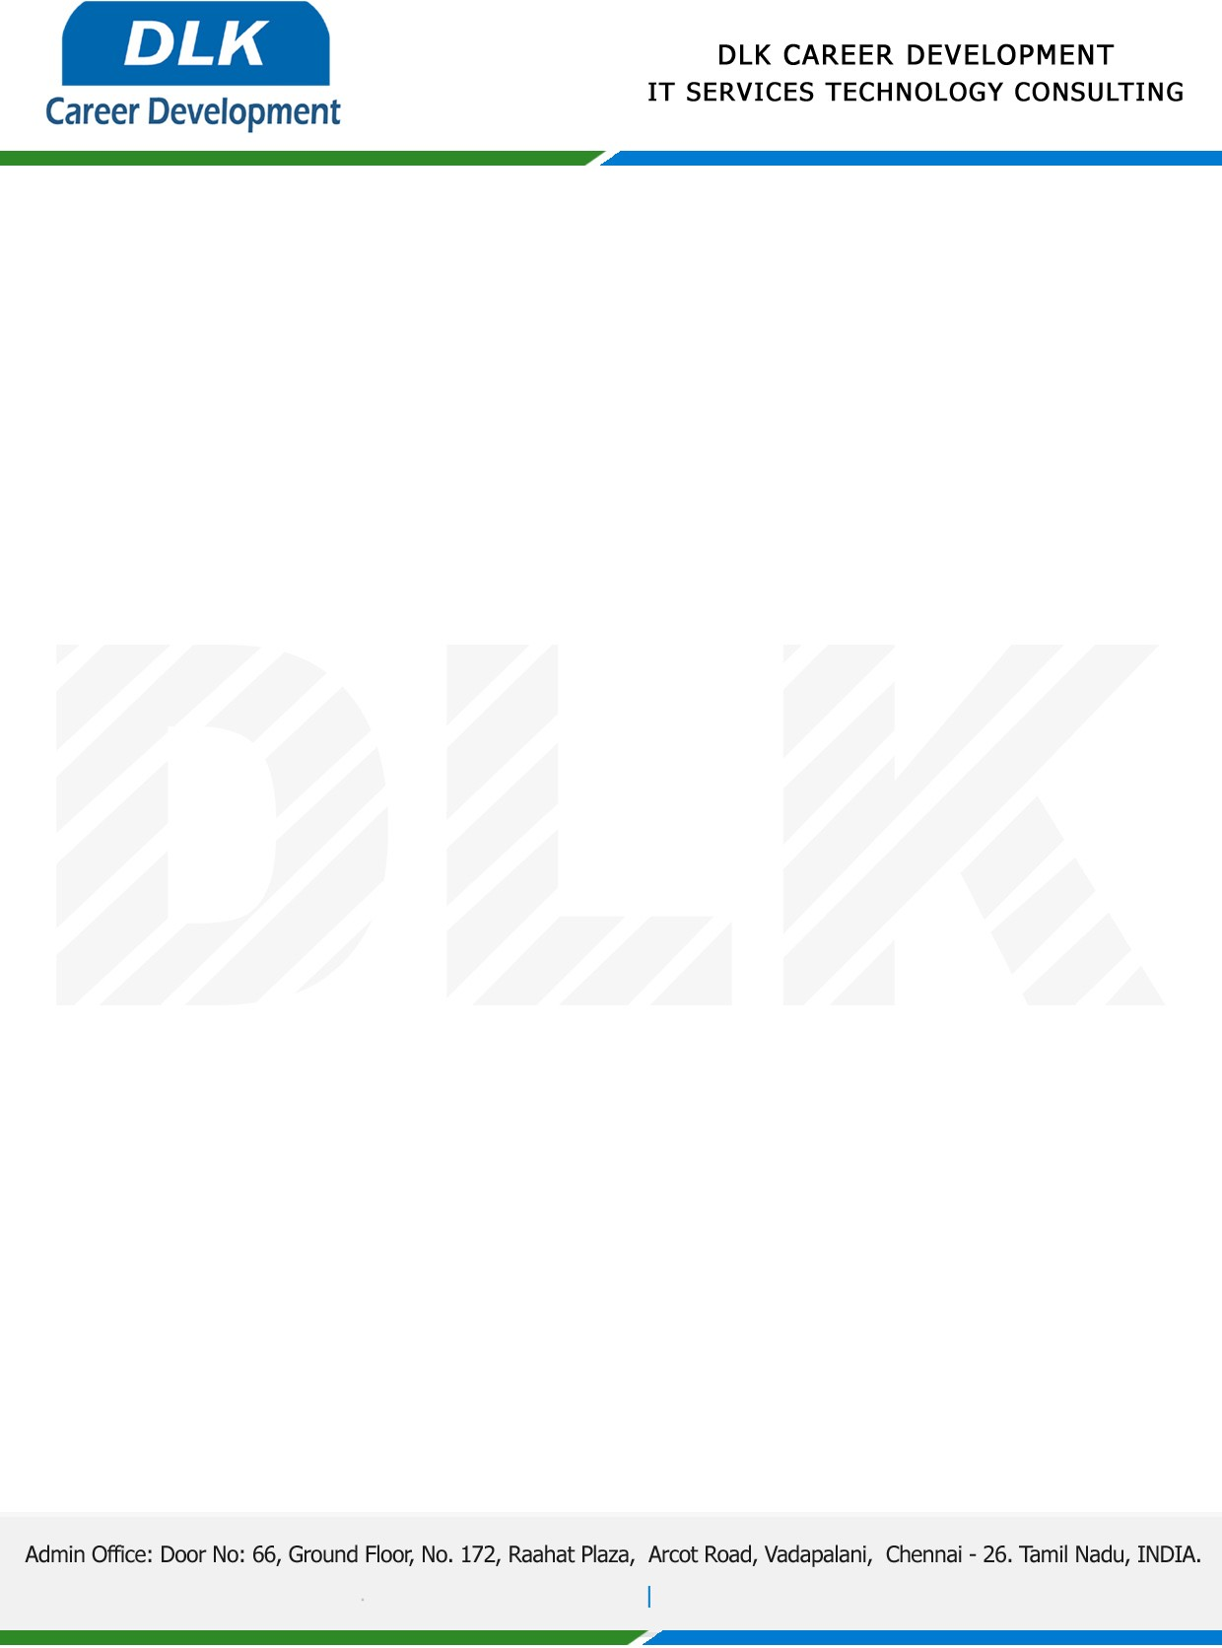

Date: 31/January/2023

**To**

Department of BE (Computer Science Engineering),

Head of Department,

Meenakshi Sundararajan Engineering College, Chennai.

**Sub: Letter of Internship Acceptance**

This is to certify that final year student of has accepted the Project work duration from **(1st February 2023 to 30th April 2023)** under the domain **“Python”.** During the Project, all information and data collected from you should be kept confidential.

**Team Members:**

1. MR SANTHOSH S (311519104051)
2. MR AKASH K V (311519104301)
3. MR RAJAISHANKAR P (311519104302)

**Topic:** Automated Resume Recommendation System

We appreciate your interest in **DLK CAREER DEVELOPMENT**

For **DLK CAREER DEVELOPMENT**

**HR Manager**

**VELMURUGAN J**